**CST-391 Milestone 1 Guide**

## **Project Overview**

In this course, you will work to design and build two web applications with similar functionality using two front-end JavaScript frameworks, React and Angular. These will both use a server you will write using the Express JavaScript framework. Figure 1 shows a high-level view of what will be built:

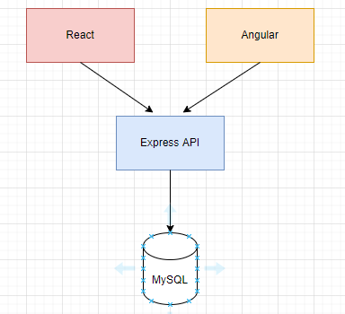

Figure 1. *Milestone Application Architecture*

At the ten-thousand-foot view, the milestone project looks the same as the activity assignments. The difference is in the details. The activities are guided tutorials, while the milestones are guided by your design. The database, the API, and the UIs developed in the milestones are all your design. The minimum requirements for the milestones are simpler than the activities.

### The project will support the following high-level requirements:

* The minimum requirement is to support a product. A product is any object that can be represented as a class with multiple properties. Your product should include properties with at least three different data types in the MySQL database. The web application should implement the abilities to list, create, read, update, and delete a "product."
* Design and develop back-end services using Express and NodeJS that will be used by two front-end web applications. The implementation of the REST API should simply be a façade over any business logic required to process the back-end data and relational database using MySQL.
* Design and develop a front-end web application using the Angular JavaScript Framework. The web application should be integrated with the REST APIs developed using Express.
* You will redevelop the same front-end web application, this time using the React JavaScript Framework.
* Christian Theme. As an option, consider using a biblical or Christian worldview theme for the project. Consider building an app that serves an organization you support. Consider looking for "products" such as bible verses, prayers, contacts, events, images, devotions, commentary, songs, etc. that you could track via this application. Finally, for inspirational ideas, look at some lists of existing mobile apps designed for Christian communities, located in the topic Resources.
* Document all technical decisions and technical designs via the design report. This report will capture all appropriate UML diagrams, ER diagrams, UI designs, and other technical artifacts to support the design of the end-to-end solution and application.

### Deliverable

For Milestone 1, you will create a project proposal that defines the functionality that will be delivered through the next five milestone assignments, supporting the high-level requirements defined in the "Project Overview" section of this document.

The project proposal, written in Microsoft Word, should contain the following sections labeled in this order:

* Cover Sheet: Class number and title, application name, and author.
* Introduction: Description of the application being developed.
* Functionality Requirements: List of requirements in User Story format.
* Initial Database Design: ER Diagram.
* Initial UI Sitemap: Logical layout and flow of application pages/modules.
* Initial UI Wireframes: Low-fidelity user interface designs.
* Initial UML Classes: The back-end services and object model class designs.
* Risks: Unknowns and risks that need to be tracked during the project.